Amazon Lightsail Project:

AWS Project: Deploy a WordPress website with Amazon Lightsail.

-WordPress website with Amazon Lightsail:

# Amazon Lightsail service provides easy-to-use and simplified cloud resources to get your web application or websites up and running in just a few clicks. It offers virtual servers, storage, databases, and networking, plus a cost-effective monthly plan for using the service. With Lightsail, we can easily spin up websites or applications on a Virtual Private server using pre-configured blueprints like WordPress, Prestashop, or LAMP.

# Problem Statement:

A customer wanted to simplify the process that takes to host a WordPress website on AWS, which would allow her to connect with audiences around the globe. Also, the customer didn't want to pay a lot for the services.

# Solution Statement:

The best option for the customer was to create her WordPress website with Amazon Lightsail because Lightsail provides easy to use method to get a web application or website up and running in just a few clicks. Most importantly, Amazon Lightsail has a cost-effective monthly plan for services that run the website.

# In this project, I am going to launch a WordPress website with Lightsail and provide a static IP address to the instance. Also, I am going to create a DNS zone for the site domain and map it to the instance for easy access.

# Creating the instance and selecting the AWS region

# Selecting the platform for the WordPress to build the website

# Selecting the instance price options

# The Website InstanceGraphical user interface, text, application

Description automatically generated

# Creating a static IP address for the instanceGraphical user interface, text, application, email

Description automatically generated

# Login into the WordPress site

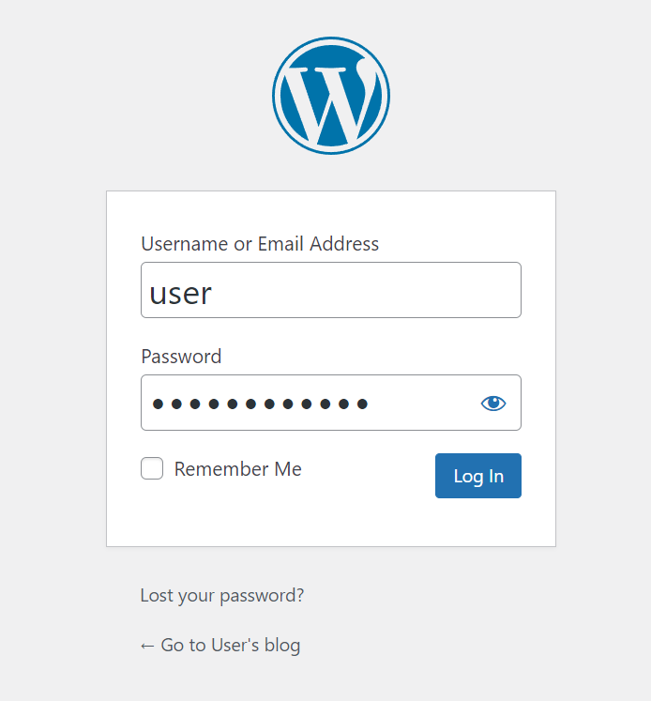

# Displaying one of the WordPress page

I created a DNS zone for the site and used Route 53 to manage the DNS records.